**CODE REPORT**

**Theory:**

We’ve fading channel coefficient is,

$$h= \sum_{i=0}^{l-1}{a_{i}\cos{2πF_{c}τ_{i}-j\sum_{i=0}^{l-1}{a_{i}\sin{2πF_{c}τ_{i}}}}}$$

where, $F_{c}$ is career frequency

$τ_{i}$ is delay in $i^{th}$ path.

$a_{i}$ is attenuation factor

It can be written as,

$$h=x+jy$$

where, $x= \sum_{i=0}^{l-1}{a_{i}\cos{2πF_{c}τ_{i}}}$, $y= -\sum_{i=0}^{l-1}{a_{i}\sin{2πF_{c}τ_{i}}}$

Where x and y are sum of a large set of random variables because of random attenuation ($a_{i}$) and random delay ($τ_{i})$. When we add a large set of random component variables, it results a Gaussian distribution by central limit theorem.

Now $x$ and $y$ assumed to be Gaussian Random variable with probability distribution function are $F_{X}\left(x\right)=\frac{1}{\sqrt{π}}e^{-x^{2}}$ and $F_{Y\left(y\right)}=\frac{1}{\sqrt{π}}e^{-y^{2}}$ respectively.

Writing $h$ as magnitude and phase form we get,

$$h=ae^{j∅}$$

where, $a= \sqrt{x^{2}+y^{2}}$, $ϕ= \tan^{-1}{\frac{y}{x}}$

where, the marginal distribution of $a$ we get after integration is $F_{A}\left(a\right)=2ae^{-a^{2}}$ ( $i.e$ Rayleigh distribution.)

In case of $∅,$ we get the marginal distribution $1/2π$ ($i.e$ uniform distribution).

**Code Workflow:**

Using the function

numpy.random.randn(N)

We can generate an array of normally distributed random numbers of size N with mean zero and unity standard variation.

The snippet below

h = (1/numpy.sqrt(2))*(numpy. random.randn(N) + numpy. random.randn(N)*1j)

creates an array of complex numbers with random components of size N=100000 with mean zero and variance 1/2.

With the help of abs function we calculated magnitude(modulus) of all elements and stored in array a.

And created the histogram class of above array a with uniform class size of 0.05 using the following snippet

pdfa, bin_edges = np.histogram(a,np.arange(0,4.05,0.05))

Probability of each histogram class can be calculated as,

$P\left(i^{th} class\right)=\frac{frequency of i^{th} class}{N}$

And, approximate density of each histogram class can be seen as,

$PD\left(i^{th}class\right)=\frac{P\left(i^{th}class\right)}{size of i^{th}class}$

Now plot of amplitude(magnitude) probability density is figured using following snippet,

#get plot of modulus graph

fig1 = plt.figure()

ax = fig1.add_axes([0,0,1,1])

ax.bar(np.arange(0,4,0.05), [ele/N/0.05 for ele in pdfa])

ax.set_title('PDF of Amplitude')

which generates graph like,

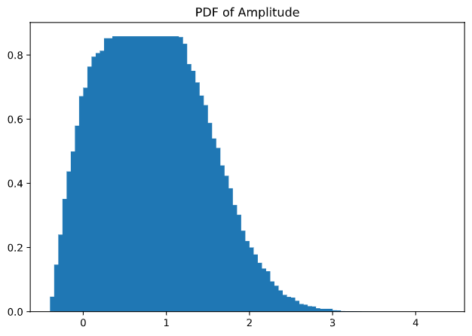

Indeed, the graph comes out to a Rayleigh distribution at $a$ = $(Approx.) 0.71± 0.05$ have maximum probability density value $0.85$.

Similarly, in case of $ϕ(Phase Graph)$ we get the graph below, In the following graph it can be seen that it follows nearly uniform distribution with $p=.16(approx.)$

